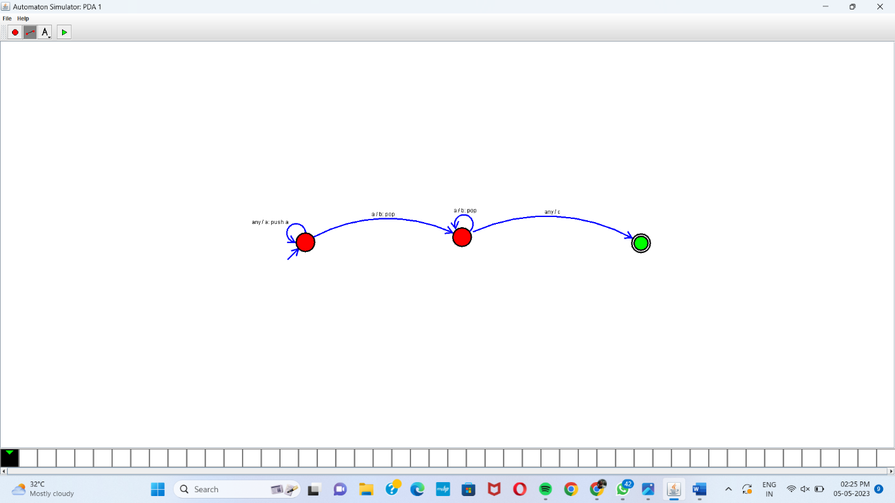

Automaton Simulator, v1.0

dpda {

alphabet {abcd\*}

state {

initial {yes}

coord {654 431}

}

state {

coord {990 420}

}

state {

final {yes}

coord {1374 433}

}

edge 0 0 {

transits {a}

offset {2.356194490192345}

action {push a}

}

edge 0 1 {

transits {b}

offset {0.5235987755982988}

stacktop {a}

action {pop}

}

edge 1 1 {

transits {b}

offset {1.427838827201176}

stacktop {a}

action {pop}

}

edge 1 2 {

transits {c}

offset {0.5235987755982988}

}

}